Course Outline  
Week 1&2

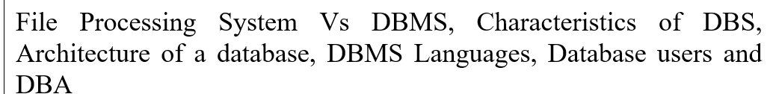 Sure, here's a more detailed explanation of each aspect:

**1. File Processing System vs. DBMS:**

- File Processing System: This is an older method of managing data where each application has its own set of files. It lacks centralized control, meaning different applications may have their own files and formats, leading to redundancy and inconsistency.

- DBMS (Database Management System): DBMS provides centralized control over data storage, retrieval, and manipulation. It offers a structured approach to managing data, reducing redundancy and inconsistency by providing a single, integrated view of data across the organization.

**2. Characteristics of DBMS:**

- Centralized data management: All data is stored in a centralized location, providing a single source of truth.

- Data integrity: DBMS ensures that data remains accurate, consistent, and valid throughout its lifecycle.

- Concurrent access control: DBMS manages multiple users accessing the database simultaneously, ensuring data integrity and consistency.

- Security mechanisms: DBMS provides authentication and authorization mechanisms to control access to data and ensure data privacy and security.

- Backup and recovery: DBMS offers mechanisms to backup data regularly and recover it in case of data loss or system failure.

- Data independence: DBMS provides abstraction layers that separate the physical storage of data from the logical representation, allowing changes in one without affecting the other.

**3. Architecture of a Database:**

- Three-tier architecture: This architecture separates the user interface, application logic, and database storage into distinct tiers.

- Presentation tier: This is the user interface where users interact with the system.

- Application tier: This tier contains the business logic and processes requests from the presentation tier.

- Data tier: This tier comprises the database server where data is stored and managed.

**4. DBMS Languages:**

- Data Definition Language (DDL): DDL is used to define the structure of the database, including creating, modifying, and deleting database objects such as tables, indexes, and constraints.

- Data Manipulation Language (DML): DML is used to manipulate data within the database, including inserting, updating, deleting, and querying data.

- Data Control Language (DCL): DCL is used to control access to data, including granting and revoking permissions to users and roles.

**5. Database Users and DBA (Database Administrator):**

- Database users: These are end-users who interact with the database system to perform various operations such as querying data, updating records, and generating reports.

- DBA (Database Administrator): The DBA is responsible for managing and maintaining the database system. This includes tasks such as database design, performance tuning, security management, backup and recovery, and ensuring overall system availability and reliability.

These elements collectively ensure efficient and effective management of data within an organization, providing users with reliable access to the information they need while maintaining data integrity, security, and availability.

Week 3  
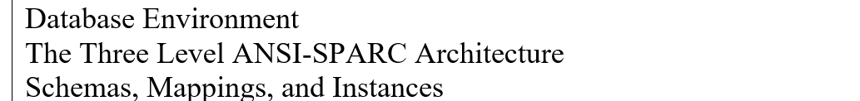

Certainly! Here's a more detailed explanation of each aspect:

**1. Database Environment:**

- Hardware: The physical components, such as servers and storage devices, used to store and process data.

- Software: The programs and applications that manage and access the data.

- Data: The information stored in the database.

- Procedures: The rules and guidelines for managing and accessing the data.

- Users: The individuals or applications that interact with the database.

- Environment: The context or setting in which the database operates, including factors such as network connectivity and system resources.

**2. The Three-Level ANSI-SPARC Architecture:**

- External level: This is the view of the database as seen by the end-users or applications. It represents the portion of the database relevant to a particular user or application.

- Conceptual level: This is the community view of the database. It represents the entire database and includes all entities, relationships, and constraints.

- Internal level: This is the physical representation of the database on the storage media. It includes details such as data structures, storage organization, and access methods.

**3. Schemas, Mappings, and Instances:**

- Schema: A schema is a logical description of the entire database. It defines the structure of the database, including tables, attributes, relationships, and constraints.

- Mappings: Mappings define how data in the conceptual schema is mapped to the internal schema and how data in the external schema is mapped to the conceptual schema.

- Instances: An instance is a snapshot of the database at a particular moment in time. It represents the actual data stored in the database.

These concepts collectively provide a comprehensive understanding of the organization, structure, and functioning of a database system, enabling efficient data management and retrieval.

Week 4 and 5

 Certainly! Let's delve deeper into data models and conceptual modeling, focusing on hierarchical and network data models:

**1. Data Models:**

- Definition: Data models are abstract representations of the structure and relationships within a database. They define how data is organized, stored, and accessed in a database system.

- Purpose: Data models provide a conceptual framework for understanding and manipulating data. They serve as blueprints for designing databases and ensuring data integrity and consistency.

- Types: Common types of data models include hierarchical, network, relational, object-oriented, and NoSQL models, each with its own characteristics and use cases.

**2. Conceptual Modeling:**

- Definition: Conceptual modeling is the process of creating a high-level representation of the data within a database system. It involves identifying entities, attributes, relationships, and constraints relevant to the application domain.

- Purpose: Conceptual models provide a clear understanding of the data requirements and help bridge the gap between business needs and database design. They facilitate communication among stakeholders and guide the development process.

- Independence: Conceptual models are independent of any specific implementation or technology, focusing on capturing the essential aspects of the data without getting into technical details.

**3. Hierarchical Data Model:**

- Structure: In a hierarchical data model, data is organized in a tree-like structure with parent-child relationships. Each parent record can have multiple child records, but each child record has only one parent.

- Use Cases: Hierarchical models are well-suited for representing one-to-many relationships where each parent can have multiple children. They are commonly used in applications such as file systems, organizational charts, and XML documents.

- Limitations: Hierarchical models can be restrictive when dealing with complex data relationships, as they don't easily support many-to-many relationships.

**4. Network Data Model:**

- Extension of Hierarchical Model: The network data model extends the hierarchical model by allowing each child record to have multiple parent records, forming a more flexible network of interconnected records.

- Structure: In a network model, data is represented as a collection of records connected by relationships. Records can have multiple parents and children, supporting many-to-many relationships.

- Use Cases: Network models were popular in the early days of database management systems, offering more flexibility than hierarchical models. They were used in applications where data relationships were complex and needed to be represented accurately.

- Transition to Relational Model: Despite their flexibility, network models have largely been replaced by the relational model, which offers simpler data structures and more powerful querying capabilities.

These concepts provide a foundational understanding of data modeling and conceptual modeling, essential for designing effective database systems that meet the needs of organizations and users.

Week 7

Database Management Systems (DBMS) rely on specialized languages to perform various tasks efficiently. Here's a breakdown of the key functions of these languages:

**1. Data Definition Language (DDL):**

- Purpose: DDL is used to define the structure and organization of the database schema.

- Actions: It involves commands like CREATE, ALTER, and DROP, which are used to define tables, indexes, constraints, etc.

**2. Data Manipulation Language (DML):**

- Purpose: DML facilitates the retrieval, insertion, updating, and deletion of data within the database.

- Actions: Common commands include SELECT, INSERT, UPDATE, and DELETE, allowing users to manipulate data as needed.

**3. Data Control Language (DCL):**

- Purpose: DCL manages access control to the database and its objects, ensuring data security.

- Actions: It includes commands like GRANT and REVOKE, which grant or revoke access privileges to users or roles.

**4. Transaction Control Language (TCL):**

- Purpose: TCL governs the management of transactions within the database, maintaining data consistency and integrity.

- Actions: Commands like COMMIT and ROLLBACK are used to either confirm or discard changes made during a transaction, ensuring data integrity.

In summary, these database languages provide a comprehensive suite of tools for efficiently managing databases. They allow users to define database structures, manipulate data, control access, and maintain data integrity through transaction management.

Week 7

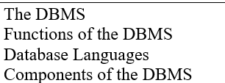

**1. DBMS:** A software system that manages databases, providing functionalities for storage, retrieval, and manipulation of data.

**2. Functions of DBMS:**

- Data Definition: Defines the structure of the database.

- Data Manipulation: Allows users to retrieve, insert, update, and delete data.

- Data Control: Enforces security and integrity constraints.

- Data Querying: Supports querying and reporting on the data.

**3. Database Languages:**

- Data Definition Language (DDL): Used to define the database structure.

- Data Manipulation Language (DML): Used to manipulate data within the database.

- Query Language: Allows users to retrieve specific information from the database.

**4. Components of DBMS:**

- Data Storage: Stores data on disk or in memory.

- Database Engine: Manages access to the data, including processing queries and transactions.

- Query Processor: Parses and executes queries.

- Transaction Manager: Ensures the ACID properties (Atomicity, Consistency, Isolation, Durability) of transactions.

- Security Manager: Enforces access control and data protection policies.

Week 8

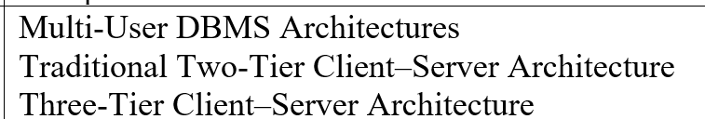

Multi-User DBMS Architectures are classified into Traditional Two-Tier Client-Server Architecture and Three-Tier Client-Server Architecture, each with distinct characteristics.

**1. Traditional Two-Tier Client-Server Architecture:**

- Description: Divided into client and server layers, with clients handling the user interface and application logic, and the server managing data storage and processing.

- Client Layer: Involves the user interface and application logic.

- Server Layer: Manages the DBMS, responsible for data storage, retrieval, and processing.

- Interaction: Clients directly communicate with the database server to request data or perform operations.

- Limitations: Potential scalability and performance issues due to concentrated processing and data access logic in the client and server layers.

**2. Three-Tier Client-Server Architecture:**

- Description: Introduces a middle tier or application server between the client and server layers.

- Client Layer: Retains responsibility for the user interface.

- Middle Tier (Application Server): Hosts application logic, including business rules and processing.

- Server Layer: Manages data storage, retrieval, and processing, similar to the two-tier architecture.

- Interaction: Clients communicate with the middle tier, which then interacts with the database server, separating presentation logic from application and data logic.

- Advantages: Enhances scalability by allowing the middle tier to handle numerous client requests. Improves security by isolating the database server from direct client access.

- Flexibility: Enables easier maintenance and upgrades as each layer can be modified or upgraded independently without affecting others.

In summary, the two-tier architecture is simpler, while the three-tier architecture offers better scalability, security, and flexibility. The latter is more suitable for modern multi-user DBMS applications.

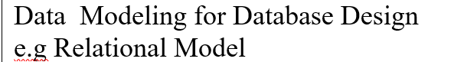 Data modeling is a crucial step in designing a database, and the widely adopted relational model provides an effective approach. Here's an overview:

**Data Modeling for Database Design (e.g., Relational Model):**

1. Entity-Relationship (ER) Modeling:

- Purpose: Initial step representing entities, their attributes, and relationships.

- Entities: Objects or concepts (e.g., customers, products) with distinguishable characteristics.

- Attributes: Properties describing an entity (e.g., customer name, product price).

- Relationships: Associations between entities (e.g., a customer placing an order).

2. Relational Model:

- Purpose: Organizes data into tables (relations) with rows and columns, ensuring relationships and data integrity.

- Tables: Represent entities; each row is a record, columns are attributes.

- Keys: Primary keys uniquely identify records, foreign keys establish relationships.

- Normalization: Minimizes data redundancy and dependency for better organization.

3. Normalization:

- Purpose: Ensures data integrity by minimizing redundancy and dependency.

- Forms: First, Second, Third Normal Forms address different aspects of data organization.

- Example: Breaking a table into smaller tables to eliminate redundant data (e.g., separating customer information from order details).

4. Structured Query Language (SQL):

- Purpose: Language to interact with relational databases.

- Queries: SELECT retrieves data, INSERT, UPDATE, DELETE modify data.

- Data Definition: CREATE, ALTER, DROP define and modify the database structure.

5. Database Integrity Constraints:

- Purpose: Constraints enforce rules for data integrity.

- Types: Primary Key ensures uniqueness, Foreign Key establishes relationships, CHECK ensures data meets specific criteria.

- Example: Ensuring each customer has a unique ID as a primary key.

In summary, data modeling, particularly in the relational model, involves ER modeling for entity relationships, normalization for minimizing redundancy, SQL for database interaction, and integrity constraints for maintaining accurate data and relationships.